**Instagram Project- SQL**

***There are 3 ways to work with SQL- MY SQL or SQL SERVER MANAGER by Microsoft, db fiddle and MODE.com***

If you are not able to create the database using the commands provided in the instructions, then please do perform the following steps:-  
  
1. Try running the code line by line on any online SQL editor of your choice.

2. Try installing My SQL on your systems and then try performing the exercise. (Recommended)

Install my sql server and my sql workbench following the instructions given in the below 3 videos.

Installation Steps:- <https://www.youtube.com/watch?v=eq-e_n7lm2M>

My SQL Workbench tutorial:- <https://www.youtube.com/watch?v=uKwR9fWsZJ4&t=1133s>

Sample Instagram Clone Database:- <https://www.youtube.com/watch?v=082qPwIJTR4>

**For online editor use - https://www.db-fiddle.com/**

**Steps to create a mode.com account:-**

**1. Go to-** [**www.mode.com**](http://www.mode.com)

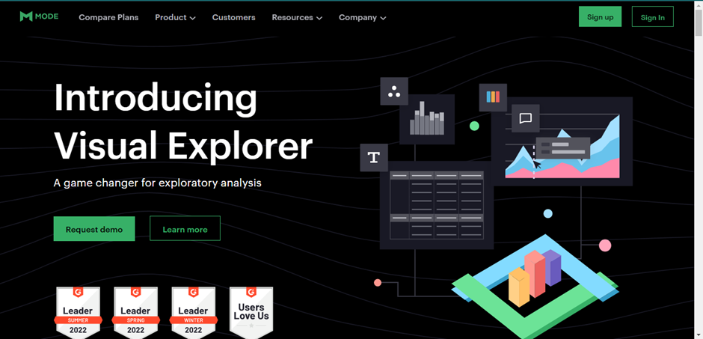

**2. Click on Sign-In button on the top right hand corner, then click on GOOGLE and sign in using your google account.**

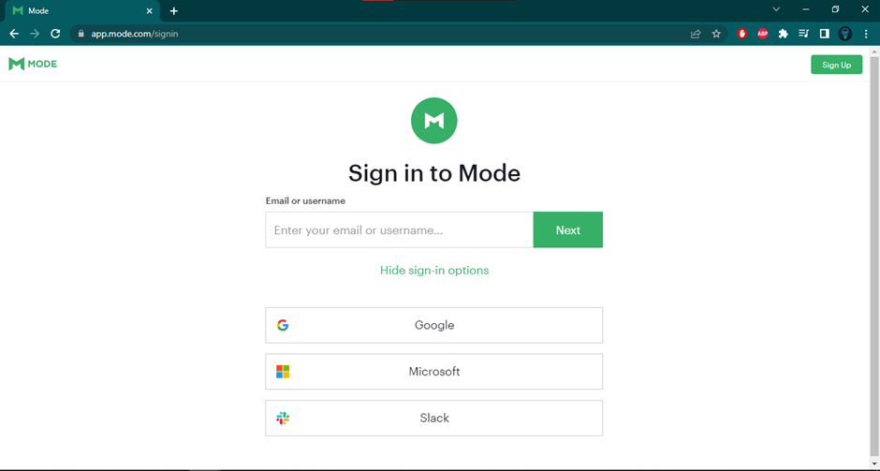

**3. Now a dashboard will open and in that you are supposed to click on “+” button which says to create a new report.**

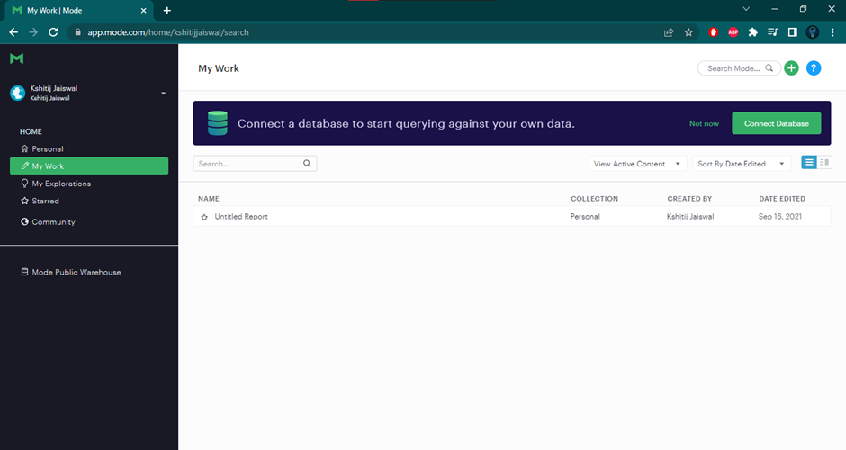

**4. After clicking the button your work is over and you have successfully created a mode account!**

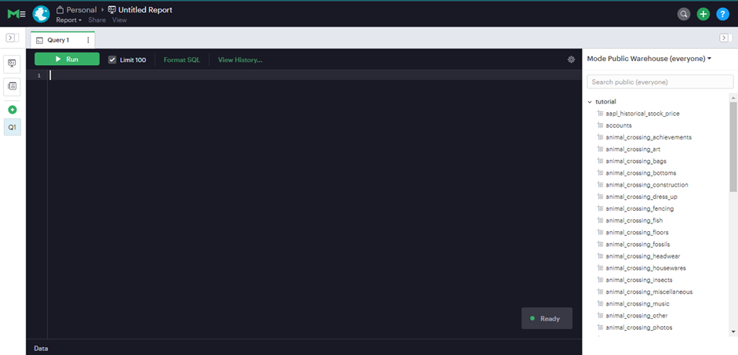

Follow these steps and you will be able to finish the project allotted to you.